

PUBLICATION OF THE NORTH JERSEY SECTION OF THE INSTITUTE OF ELECTRICAL AND ELECTRONICS ENGINEERS

North Jersey Section Celebrates 50 Years!

NJ Control Systems Society:
Elements of Aided Inertial Navigation
On December 8, 2004 the NJ Section IEEE Control Systems Society will present a talk on "Elements of Aided Inertial Navigation." The speaker will be Jack Richman.
About the Talk
Modern navigation is the process of accurately determining the continuous position, velocity, and attitude of a moving vehicle with respect to a reference coordinate frame. Inertial components (accelerometers and gyroscopes) provide continuous acceleration and angular rate information with respect to an inertial coordinate frame. Processing of this data produces continuous position, velocity and altitude of the vehicle with respect to a reference navigation coordinate frame. Since inertial component errors tend to degrade performance over time, the navigation system must be aided with occasional data from other external sources to maintain the overall accuracy. This approach is known as “aided inertial navigation” and it has received much attention and technical effort. This talk is aimed at a general engineering/technology audience and covers the following key topics:
- Inertial Components
- The processing of the inertial component data to form an Inertial Measuring Unit (IMU)
- The errors associated with an “un-aided” IMU
- The Global Positioning System (GPS)
- Optimally combining discrete GPS data with continuous IMU data via a Kalman filter to form a GPS aided IMU
About The Speaker
Jack Richman is an Adjunct Professor of Electrical Engineering at NJIT and had been an Adjunct Professor at Polytechnic University of New York for a number of years. He is a part time employee of the Applied Research Laboratory of Penn State University and a full time consultant to BAE Systems Corporation, an international aerospace company whose products include communication, navigation and identification systems. Prior to this Jack Richman was a Principal Scientist at the Kearfott Guidance & Navigation Corporation for 35 years where had worked in the areas of inertial navigation, modern control theory and optimal statistical filtering. He is the author or coauthor of numerous papers on these subjects and holds a U.S patent for a novel navigation system.

Time: 5:00 to 6:00 PM, Wednesday, December 8, 2004.
Place: New Jersey Institute of Technology (NJIT), Room 202, ECE Center, Newark, NJ. Directions are available at http://www.njit.edu/ University/Directions.html.
Information: Professor Timothy Chang (973) 596-3519 (changtn@njit.edu).

New Jersey City FIRST!
Volunteer and Mentoring Opportunities
IEEE is a proud supporter of FIRST, the organization that celebrates the achievements of young men and women working smart in science and technology.
Share your technical expertise, your organizational skills, your energy, and your heart. Everyone has something to contribute to New Jersey’s youth who represent tomorrow’s future engineering workforce:
- Be a mentor with a New Jersey high school participating in the FIRST Robotics Competition, January–March
- Be a mentor to a team of New Jersey middle school students participating in the FIRST LEGO League design challenge, October - February
- Be a volunteer at the 2005 New Jersey FIRST Robotics Competition, March 17-19, 2005
- Be a volunteer at the 2004 New Jersey FIRST LEGO League Tournaments, December 11, 2004
For more information about FIRST and its nationwide programs engaging young people in the creative process of technological innovation, please visit: www.usfirst.org.
If you would like to be a New Jersey FIRST! volunteer or team mentor, please contact Kevin Nolan at Johnson & Johnson by e-mail at knolan@ncsus .jnj.com, or by phone at (908) 655-4182.
NJ Section PACE & GOLD:
December 2004
Volume 51, Number 6
Publication No: USPS 580-500
“The IEEE Newsletter” (North Jersey Section), is published monthly except June and July by The Institute of Electrical and Electronics Engineers, Inc. Headquarters: 3 Park Avenue, 17th Floor, New York, NY 10016-5997. $1.00 per member per year (included in annual dues) for each member of the North Jersey Section. Periodicals-class postage paid at New York, NY and at additional mailing offices. Postmaster send address changes to: “The IEEE Newsletter”, 445 Hoes Lane, P.O. Box 1331, Piscataway, NJ 08855-1331. USPS 580-500 (ISSN 1076-3732).

NEWSLETTER STAFF
Editor Keith Saracinello
Business Manager Keith Saracinello
k.saracinello@ieee.org (908) 791-4067

Deadline for receipt of material is the 1st of the month preceding the month of publication. All communications concerning editorial and business matters, including advertising, should be sent to the Business Manager via e-mail at k.saracinello@ieee.org or to The IEEE Newsletter, c/o Keith Saracinello, 25 Messenger Ln, Ringoes, NJ 08551, (908) 791-4067.

IEEE NJ SECTION HOME PAGE
http://web.njit.edu/~ieeenj/
IEEE NJ SECTION NEWSLETTER HOME PAGE
http://web.njit.edu/~ieeenj/NEWSLETTER.html

REPORT ADDRESS CHANGES TO:
IEEE Service Center, 445 Hoes Lane, P.O. Box 1331, Piscataway, NJ 08855-1331, (732) 981-0060. It is not necessary to inform the North Jer-sey Section when you change your mailing address. “The IEEE Newsletter” and other section mailings use a list provided by IEEE’s national headquarters.

SECTION OFFICERS
Chairman Dr. Durga Misra
dmisra@njit.edu (973) 596-5739
Vice-Chairman-1 Har Dayal
har.dayal@baesystems.com (973) 633-4618
Vice-Chairman-2 Bhanu Chivakula
b.chivakula@computer.org (732) 718-3818
Treasurer Dr. Edward (Ted) Byrne
flatland@compuserve.com (410) 778-2768
Secretary Dr. Sanghoon Shin
s.shin@ieee.org (973) 492-1207 Ext. 22

Members-at-Large:
Dr. Nirwan Ansari (nirwan.ansari@njit.edu)
Naz Simonelli (naz@ieee.org)
Dr. Richard Snyder (r.snyder@ieee.org)

The North Jersey Section Executive Committee usually meets the first Wednesday (except holidays and December) of each month at 7:00 PM. Meetings are open to all members. For information on meeting agenda contact Secretary Dr. Sanghoon Shin at (973) 492-1207 Ext. 22, s.shin@ieee.org.
Engineers meet:
Contract Engineering - An Alternate Form of Employment
On Wednesday, December 8, 2004 the North Jersey Section Professional Activities Committee and Graduates of the Last Decade will meet to discuss contracting engineering and the job market. Bob Glynn and Paul Lorenzen will be our guest speakers from a local contract firm.
They will present their views about contract work and the job market, and be available to answer questions from the audience.
About the Meeting
One of our most successful meetings is being repeated. This meeting will bring you face to face with a representative from one of the local contract firms. Attendees will have an opportunity to discuss contract engineering, the relationship between the contract firm, client company and the contract engineer.
Topics include: the current state of the employment market for engineers, resource tools for advertising, your availability, dealing with job shops - do's and don'ts, networking - it is a contact sport, accepting positions far from home. Why this is something everyone should consider. How sending jobs offshore and importing foreign workers under the H-1B and L1 legislation have affected the business.
This meeting is NOT a job fair. Resumes can be e-mailed at a later date, but will not be necessary for the meeting.
You are encouraged to attend and bring your spouse and associates.
This is especially of interest to students, recent graduates and those looking to expand job opportunities.
About the Speakers
Bob Glynn and Paul Lorenzen of HEPCO will be our guest speakers. They are involved in all aspects of the Company with particular focus on client marketing.
HEPCO is a thirty-one year old company, headquartered in Rutherford, NJ, and currently serving clients in twenty-two states, with the balance of their work being done in the Connecticut to Virginia area. Their strategic hiring focus is across the entire spectrum of the engineering disciplines. This includes the major disciplines such as civil, electrical, environmental, and mechanical as well as subsets of these disciplines such as administrators, estimators, designers, facilities, inspectors, planners, reliability, safety, schedulers, stress analysts, and structural engineers. HEPCO provides their clients with both direct hires and consultants, who will work on a specific client project as HEPCO employees until that project is completed.
All Welcome!
Guests, members and students from other professional societies and engineering disciplines are always welcome. We now include members from IEEE, ASME and AEA. For more information about these groups see:

www.aea.org
www.asme.org/sections/northjersey
www.ieeeusa.org
web.njit.edu/~ieeenj/

Time: 6:30 to 9:00 PM, Wednesday, December 8, 2004. Refreshments will be served.
Place: Clifton Memorial Library, 292 Piaget Ave, Clifton, NJ, (973) 772-5500.
Information: Paul Ward, (973) 790-1625 (PWard1130@aol.com) or Richard F. Tax, (201) 664-6954 (rtax@AEA.org).

The NJ Section Education Committee Requests Your Feedback
The IEEE North Jersey Section has been helping fellow engineering professionals for the last fifty years. The Education Committee has successfully conducted software and engineering training courses over the last few decades. The Committee is committed to professional development of the members and the instructors for the courses are very qualified and experienced in their respective fields. Classes are arranged on weekday evenings or on Saturdays provided at least fifteen candidates are available. Completion certificates are issued by IEEE Headquarters with CEU credits for the number of training hours.
Due to the slow growth of the economy and several other factors, registration for these courses has diminished over the last few years. I would urge members to send their feedback regarding what courses they would be interested in, the format, location, and day/time, etc., by email to b.chivakula@computer.org.

Regards,
Bhanu Chivakula
Chair, Education Committee
Vice Chair, IEEE North Jersey Section

IEEE North Jersey Section Activities
NJ PES/IAS Chapters:
Distributed Generation Using Gaseous Fueled Reciprocating Engine-Generators

On December 9, 2004, the Power Engineering and Industrial Applications Chapters will present a discussion on Distributed Generation using Lean-Burn, gas fired, spark ignited “Recips” to burn either:

1. Purchased, Natural Gas or

2. “Free” Biogas from landfills, sewage plants etc.

The leader of the discussion will be Ron Williamson.
About the Talk
The discussion will focus on Lean-Burn, gas-fired power plants up to 15-20 megaWatts using reciprocating engines in the 300kW to 3mW range. Systems burning Biogas usually sell electric power back to the utility company. Systems burning natural gas usually generate Combined Heat & Power (CHP) to make the economics viable. The majority of these systems operate in parallel with the electric utility grid.
Topics to be covered:
- NJ SOTA emission requirements
- Grant money available
- Lean-Burn technology
- Heat recovery equipment in a typical CHP plant
- Electrical interconnection
- Engine efficiency
- Characteristics of Gas Turbines compared to Reciprocating Engines
- Wellesley College CHP installation
About the Speaker
The leader of the discussion will be Ron Williamson. Ron has a BS degree in Electrical Engineering and over 25 years experience in paralleling engine-generators with each other and with the utility grid. Ron presently works for Northeast Energy Systems, a division of Penn Detroit Diesel Allison in Philadelphia. NES is Authorized Distributor for G.E. Jenbacher Gaseous Fueled Power Systems. Ron is the Sales Engineer for the NY/NJ metropolitan area.

Time: 7:00 PM, Thursday, December 9, 2004. A pre-meeting buffet will be available at 6:30 PM.
Place: Eaton Electrical, 690 Rahway Ave, Union, NJ. Directions: Route 82 Morris Ave from either Springfield or Union to Rahway Ave.
Information: Ronald W. Quade, P.E., (732) 205-2614 (RWQuade@IEEE.org).
December 2004

Dec. 2 – “Annual Planning Meeting & Workshop” - NJ Consultants' Network, 7:30 PM, Aeroflex/KDI-Integrated Products, 60 S. Jefferson Rd, Whippany, NJ. Robert Walker (973) 728-0344 or www.TechnologyOnTap.org.
Dec. 7 – “Reduced-Rank Multi-User Detectors for CDMA Systems” - NJ Communications Chapter, 6:15 PM (refreshments at 6:00 PM), New Jersey Institute of Technology (NJIT), Room 202, ECE Center, Newark, NJ. Dr. Nirwan Ansari (973) 596-3670 (nirwan.ansari@njit.edu) or check http://web.njit.edu/~ieeenj for the latest updates.
Dec. 8 – “Minter Electronic Aircraft Safety Warning System” - NJ Section, 7:00 PM (pre-meeting buffet at 6:00 PM), Public Meeting Room, Morris County Library, 30 E. Hanover Ave, Whippany, NJ, (973) 285-6930. Howard Leach (973) 540-1283, h.leach@ieee.org..
Dec. 8 – “Elements of Aided Inertial Navigation” - NJ Control Systems Society, 5:00 – 6:00 PM, NJIT, 202 ECE Center, Newark, NJ. Professor Timothy Chang (973) 596-3519 (changtn@njit.edu).
Dec. 8 – “Engineers Meet: Contract Engineering - An Alternate Form of Employment” - NJ PACE/GOLD/SAC, 6:30 – 9:00 PM, Clifton Memorial Library, 292 Piaget Ave, Clifton, NJ. Paul Ward, (973) 790-1625 (PWard1130@aol.com) or Richard F. Tax, (201) 664-6954 (rtax@AEA.org).
Dec. 9 – “Distributed Generation Using Gaseous Fueled Reciprocating Engine-Generators” - NJ IAS/PES Chapters, 7:00PM (buffet at 6:30 PM), Eaton Electrical, 690 Rahway Ave, Union, NJ. Ronald W. Quade, P.E., (732) 205-2614 (RWQuade@ IEEE.org).
Dec. 13 – “Fuzzy Reasoning Petri Nets for Fuzzy Rule-Based Systems” - NJ SMC Society, 7:00 PM (light refreshments at 6:45 PM), NJIT, 202 ECE Center, Newark, NJ. Dr. Mike Liechenstein (973) 471-0721 (m.liechenstein@ieee.org), Dr. Meng Chu Zhou (mengchu.zhou@njit.edu), or Dr. Meimei Gao (gaomeime@shu.edu).
Dec. 14 – “The Impact of Automation on the Healthcare System” - NY IM & EMBS Chapters, 7:30 PM (pre-meeting reception with refreshments at 6:30 PM), Manhattan College, LEO Engineering Building, Scala Academy Room, Manhattan, NY. 718-862-7153.

Upcoming Meetings

Jan. 5 – “NJ Section Executive Committee Meeting” - 7:00 PM, ITT, 100 Kingsland Rd, Clifton, NJ. Dr. Sanghoon Shin at (973) 492-1207 Ext. 22 or s.shin@ieee.org.
Feb. 22-Apr. 19 – “Marketing Research” – North Jersey Section, Tuesday Evenings, 8 sessions, 6:30-9:00 PM, NJ International Bulk Mail Center, 80 County Rd, Jersey City, NJ. Bhanu Chivakula (b.chivakula@computer.org).

Members and Non-Members Welcome
PLEASE POST
NJ Communications Society:
Reduced-Rank Multi-User Detectors for CDMA Systems
On December 7, 2004, the IEEE North Jersey Section Communications Society Chapter along with NJIT will host a presentation on “Reduced-Rank Multi-User Detectors for CDMA Systems.” The speaker will be Dr. Hongya Ge.
About the Talk
Due to the high dimensionality of the measurement data sets as well as the changing dynamics of wireless communication systems, computationally efficient reduced-rank solutions are preferred to their full-rank counterparts in applications such as channel estimation, system synchronization, multi-user detection, and adaptive beam-forming.
This talk introduces the framework of designing reduced-rank multi-user detectors for wireless DS/SS CDMA systems. With the notion of expanding subspaces, we construct the reduced-rank multi-user detectors progressively using the simple structure of filter banks (analysis filters and synthesis filters) – the discrete-time filter vectors contained in the expanding Krylov subspaces. We further provide computationally efficient iterative methods for implementing the reduced-rank multi-user detectors along with the geometric interpretations on the filter evolution and error reduction. We prove the existence (sufficient and necessary conditions) of warp convergence in the reduced-rank multi-user detectors for designed CDMA systems, as well as in the adaptive beam-former for multi-sensor array systems. Finally, application examples are presented to demonstrate the enabling capability of the warp convergence in designed communication systems, i.e. the reduced-rank solution delivers the full-rank performance.
About the Speaker
Hongya Ge received her BS degree from the University of Electronic Science and Technology of China (UESTC), Chengdu, China; MS degree from the Nanjing University of Aeronautics and Astronautics, Nanjing, China; and PhD degree from the University of Rhode Island, Kingston, RI, in 1982, 1985, and 1994, respectively, all in electrical engineering. From 1986 to 1990, she was with the Department of Information and Electronics at the Zhejiang University, as a lecturer, teaching and researching in Radar Signal Processing, Communication Theory, and Numerical Analysis. Since 1995, she has been with the Department of Electrical and Computer Engineering, New Jersey Institute of Technology, Newark, NJ, where she is currently an associate professor. During the academic year of 2000-2001, she was a visiting scientist in the Applied Research Department of Telcordia Technologies, Inc., NJ, working on broadband wireless access, MIMO transceiver systems, and wireless network security projects. During the academic year of 2003-2004, she spent her sabbatical leave with the Colorado State University and the Nanyang Technological University, Singapore. Her research interests are in the general areas of Statistical Signal and Array Processing, Transceiver Design for Wireless Communications and Reduced Rank Adaptive Subspace Methods for Detection, Estimation, Synchronization, Tracking, Adaptive Beamforming and Interference Suppression.
Dr. Ge has published 70+ technical papers in International Journals and Conference Proceedings. She currently serves as a member of the IEEE Technical Committee on Sensor Array and Multichannel (SAM) Signal Processing, the Editorial Board of the EURASIP Journal on Wireless Communications and Networking, and the Editorial Board of the IEEE Transactions on Signal Processing. From 1998-2001, she was the Vice Chair and Chair for the Chapter of Communications Society of IEEE North Jersey Section. Since 1999, she has been on the Planning Committee for the Annual Wireless and Optical Communications Conference (WOCC). She was the Chair for the Wireless Program of the WOCC-2003.
All Welcome!
You do not have to be a member of the IEEE to attend. Bring your friends.

Time: 6:15 PM (refreshments start at 6:00 PM), Tuesday, December 7, 2004.
Place: New Jersey Institute of Technology (NJIT), Room 202, ECE Center, Newark, NJ. Directions are available at http://www.njit.edu/ University/Directions.html.
Information: Dr. Nirwan Ansari (973) 596-3670 (nirwan.ansari@njit.edu) or check http://web.njit.edu/~ieeenj for the latest updates.
NJ Consultants' Network:
Annual Planning Meeting & Workshop
On December 2, 2004, the IEEE Consultants’ Network of Northern NJ (CNNNJ) will host their Annual Planning Meeting & Workshop.
About the Meeting
In a combined November/December meeting, the IEEE Consultants Network of Northern NJ (CNNNJ) will plan the network’s direction and activities for the year 2005. We will discuss ideas and set expectations for the various network functions. Network members and any consultants considering joining the network are welcome to attend and participate.
Results of the annual election of officers will be announced at this meeting.
Traditionally, this working session is an open, informal forum to determine what the IEEE-CNNNJ is doing right, or wrong. The floor will be open to suggestions for improvements, recommendations of new network directions and activities, and proposals for new feature topics for the general meetings.
The functions performed by the IEEE Consultants Network throughout the year include:
- Monthly General Meetings – Suggested feature topics will be discussed.
- Member Networking – Member presentations and alternate formats to improve networking.
- Group Marketing & Image Building – CNNNJ website, tri-fold and postcard mailing, CNNNJ’s free consultant referral service, and alternate publicity methods.
We will have our end-of-year networking party, with refreshments, at the close of the session.
All Welcome!
Everyone welcome. No registration needed. Free admission.
About the Consultants’ Network
Founded in 1992, the IEEE Consultants Network of Northern NJ encourages and promotes the use of independent technical consultants by business and industry.

Time: 7:30 PM, Thursday, December 2, 2004.
Place: Aeroflex/KDI-Integrated Products, 60 S. Jefferson Rd, Whippany, NJ. (Entrance at rear of building)
Information: For directions and up-to-date meeting status, call Robert Walker (973) 728-0344 or visit our website at www.TechnologyOnTap.org. To download a map to KDI, go to: http://www.mcekdi-integrated.com/ directions.htm.
North Jersey SMC Society:
Fuzzy Reasoning Petri Nets for Fuzzy Rule-Based Systems
On Monday, December 13, 2004, the NJ Systems, Man and Cybernetics (SMC) Chapter will host a talk on “Fuzzy Reasoning Petri Nets for Fuzzy Rule-Based Systems.” The speaker will be Dr. Meimei Gao.
About the Talk
Fuzzy rule-based systems, consisting of a set of fuzzy if-then rules, provide the basis for so-called “expert systems” which are widely used in many fields, such as control, diagnosis, and decision making. Petri nets is a graphic and mathematical tool to model and analyze discrete event systems, such as distributed systems, communication networks, transportation systems, and manufacturing systems. In this talk, the connection between fuzzy rule-based systems and Petri nets will be explored and discussed. A particular kind of extended Petri net format - Fuzzy Reasoning Petri Net (FRPN) model for fuzzy rule-based systems will be described. The graphic structure of an FRPN model makes the model of a fuzzy rule-based system simple and legible. A formal reasoning algorithm based on the model for automatic fuzzy reasoning will be discussed. The algorithm has parallel reasoning ability. An example from a system’s fault diagnosis is used to illustrate the concepts and reasoning method.
About the Speaker
Dr. Meimei Gao is currently an Assistant Professor in the Department of Mathematics and Computer Science at Seton Hall University, South Orange, NJ. She received her BS and MS degrees from Northwestern Polytechnic University, Xi’an, China, in 1994 and 1997, respectively, and PhD Degree in Control Theory and Engineering from Shanghai Jiao Tong University, Shanghai, China, in 2000, and PhD Degree in Computer Engineering from New Jersey Institute of Technology, Newark, NJ, in 2003. Her research interests include discrete-event systems, Petri nets and applications, artificial intelligence, decision making, computer integrated manufacturing and de-manufacturing, and lifecycle engineering. She has published over 20 journal and conference proceedings papers in the above research areas. She has served as a Program Committee member for several international conferences including IEEE International Conference on Systems, Man, and Cybernetics and IEEE International Conference on Networking, Sensing and Control. She won Best Student Technical Paper Award from 2003 IEEE International Symposium on Electronics and the Environment & the IAER Electronics Recycling Summit, Boston, MA, May 2003. She is a member of IEEE and ACM.
All Welcome!
You need not be a member of IEEE to attend, and there is no charge for admission. Light refreshments will be served starting at 6:45 PM.
Please RSVP prior to the presentation since space is limited.

Time: 7:00 PM (light refreshments at 6:45 PM), Monday, December 13, 2004.
Place: New Jersey Institute of Technology (NJIT), Room 202, ECE Center, Newark, NJ. Directions are available at http://www.njit.edu/ University/Directions.html.
Information/RSVP: Dr. Mike Liechenstein, (973) 471-0721, (m.liechenstein@ieee.org), Dr. Meng Chu Zhou (mengchu.zhou@njit.edu), or Dr. Meimei Gao (gaomeime@shu.edu). Please also check electronic newsletter for any possible changes in room, etc.

NY IM & EMBS Chapters:
The Impact of Automation on the Healthcare System
On Tuesday, December 14 2004 , the New York Chapters of IM (Instrumentation & Measurement Society) and EMBS (Engineering in Medicine and Biology Society) of the IEEE New York Section will present a lecture on “The Impact of Automation on the Healthcare System.” The speaker will be Dr. Gordon Silverman.
About the Talk
With healthcare assuming an ever-growing share of GNP, rationing of medical services has become the way we have been meeting this challenge. However, instrumentation and automation provide an opportunity to address our needs, provide more effective care, and reduce costs. A review of the current status of instrument uses will be provided and a system for reeducating patients with neuromotor disorders such as stroke will be discussed in more detail. This system provides distance capabilities with numerous advantages including a significant reduction in the cost of delivery of rehabilitation services.
About the Speaker
Dr. Silverman has close to 50 years of background in the practice of engineering including experience in industry, research, teaching, and academic administration. For a number of years, he was Co-Director of the Microprocessor Laboratory at The Rockefeller University which was supported by the National Institutes of Health. While at Rockefeller he pioneered in new computer-based instrument architectures for Biomedical laboratory environments. He has published extensively including four books. His latest endeavor is as co-author of a soon to be published text entitled “Cognitive Science: Theories of the Mind.” He has served on Review Panels for the National Science Foundation and, in addition to his role as Founding Partner in PhysMed Systems Inc., he is currently Chair of Electrical and Computer Engineering at Manhattan College, and of the New York IEEE IM chapter. His immediate interests include instrument systems for Telemedicine as well as automation in the delivery of healthcare.
Dr. Silverman is currently Chief Scientist and Founding Director of Physmed Systems, Inc.

Time: 7:30 PM (pre-meeting reception with refreshments at 6:30 PM), Tuesday, December 14, 2004.
Place: Manhattan College, LEO Engineering Building (Directions below), Scala Academy Room, parking available.
Directions:
By Train: Take the Broadway #1 line to 238th Street. Walk West on 238th St one (short) block to Corlear Ave. Turn right., LEO Engineering is directly ahead.
By Car: Take Major Deegan to Exit 11 (Van Cortlandt Park So.). Proceed due West on Van Cortlandt Park So. past Broadway to Corlear Ave. (Van Cortlandt Park will be on your right as you proceed West. Do not follow sign to Manhattan College but proceed directly under the elevated subway line at Broadway. Just past the elevated subway, turn left onto Corlear Ave. LEO Engineering is on your right. Parking lot is just beyond the LEO Building.
Information/Reservations: Dr. Gordon Silverman (718) 862-7153.

Conference Rooms Needed!
The North Jersey Section (Education Committee) is looking for conference room facilities to hold their training seminars. The seminars are being held on one weeknight from 6:30 PM to 9:00 PM. In return for providing the conference facility for free, the organization can get free registration up to three members in the course/seminar. Please contact Bhanu Chivakula, Education Committee Chairman, at b.chivakula@computer.org for suggestions or discussions, if interested.
MTT/AP 19th Annual Symposium and Mini-Show

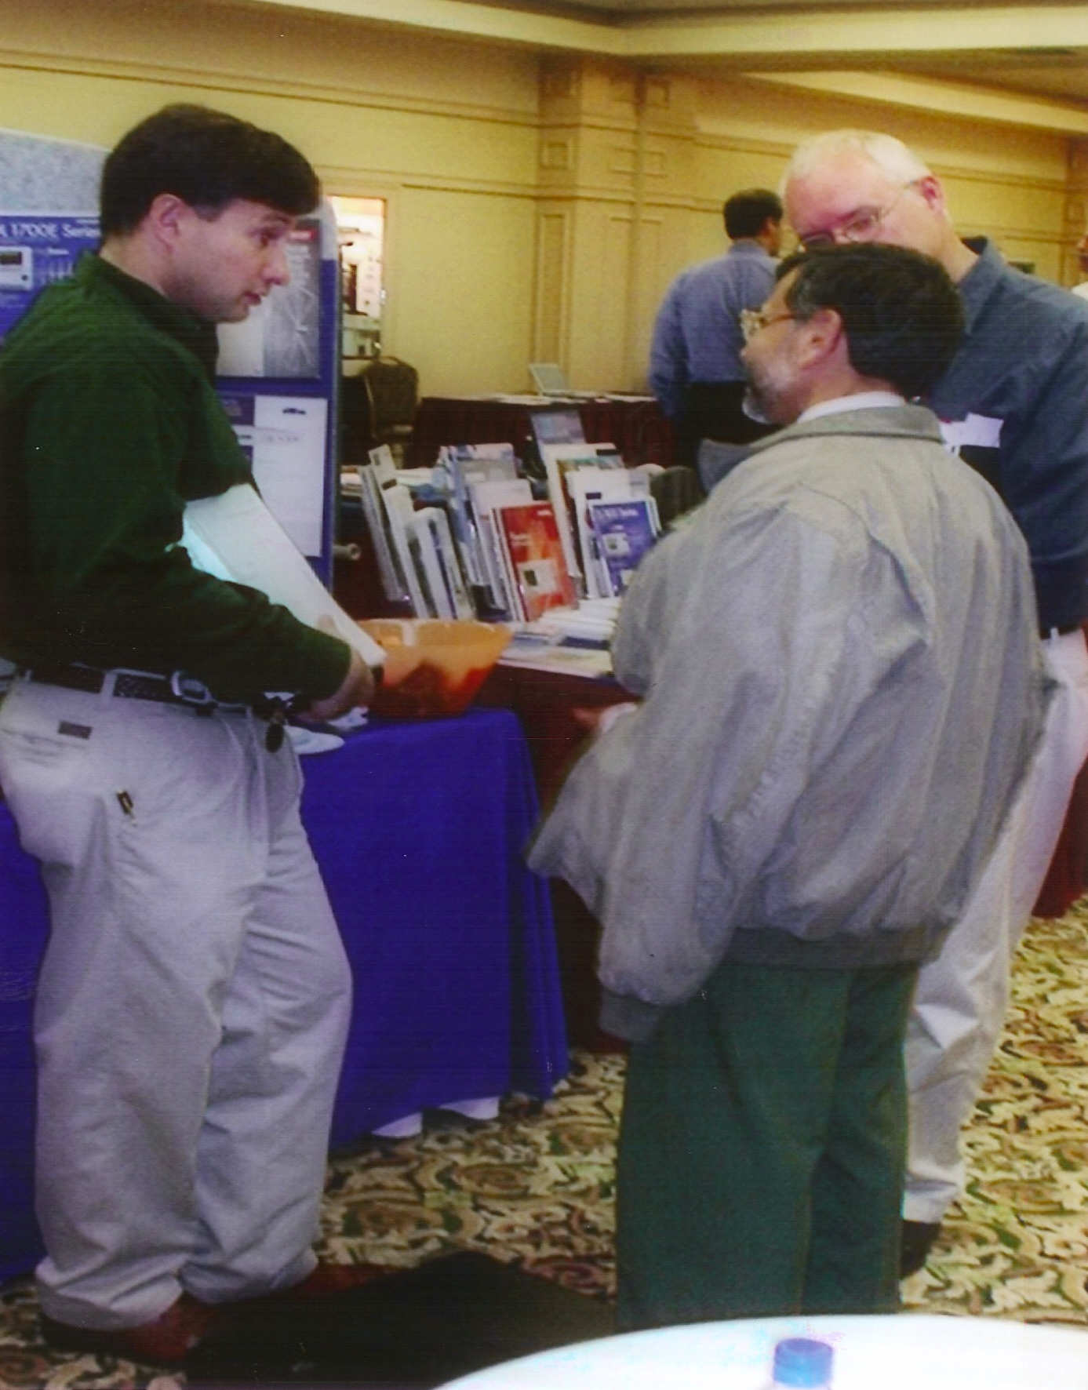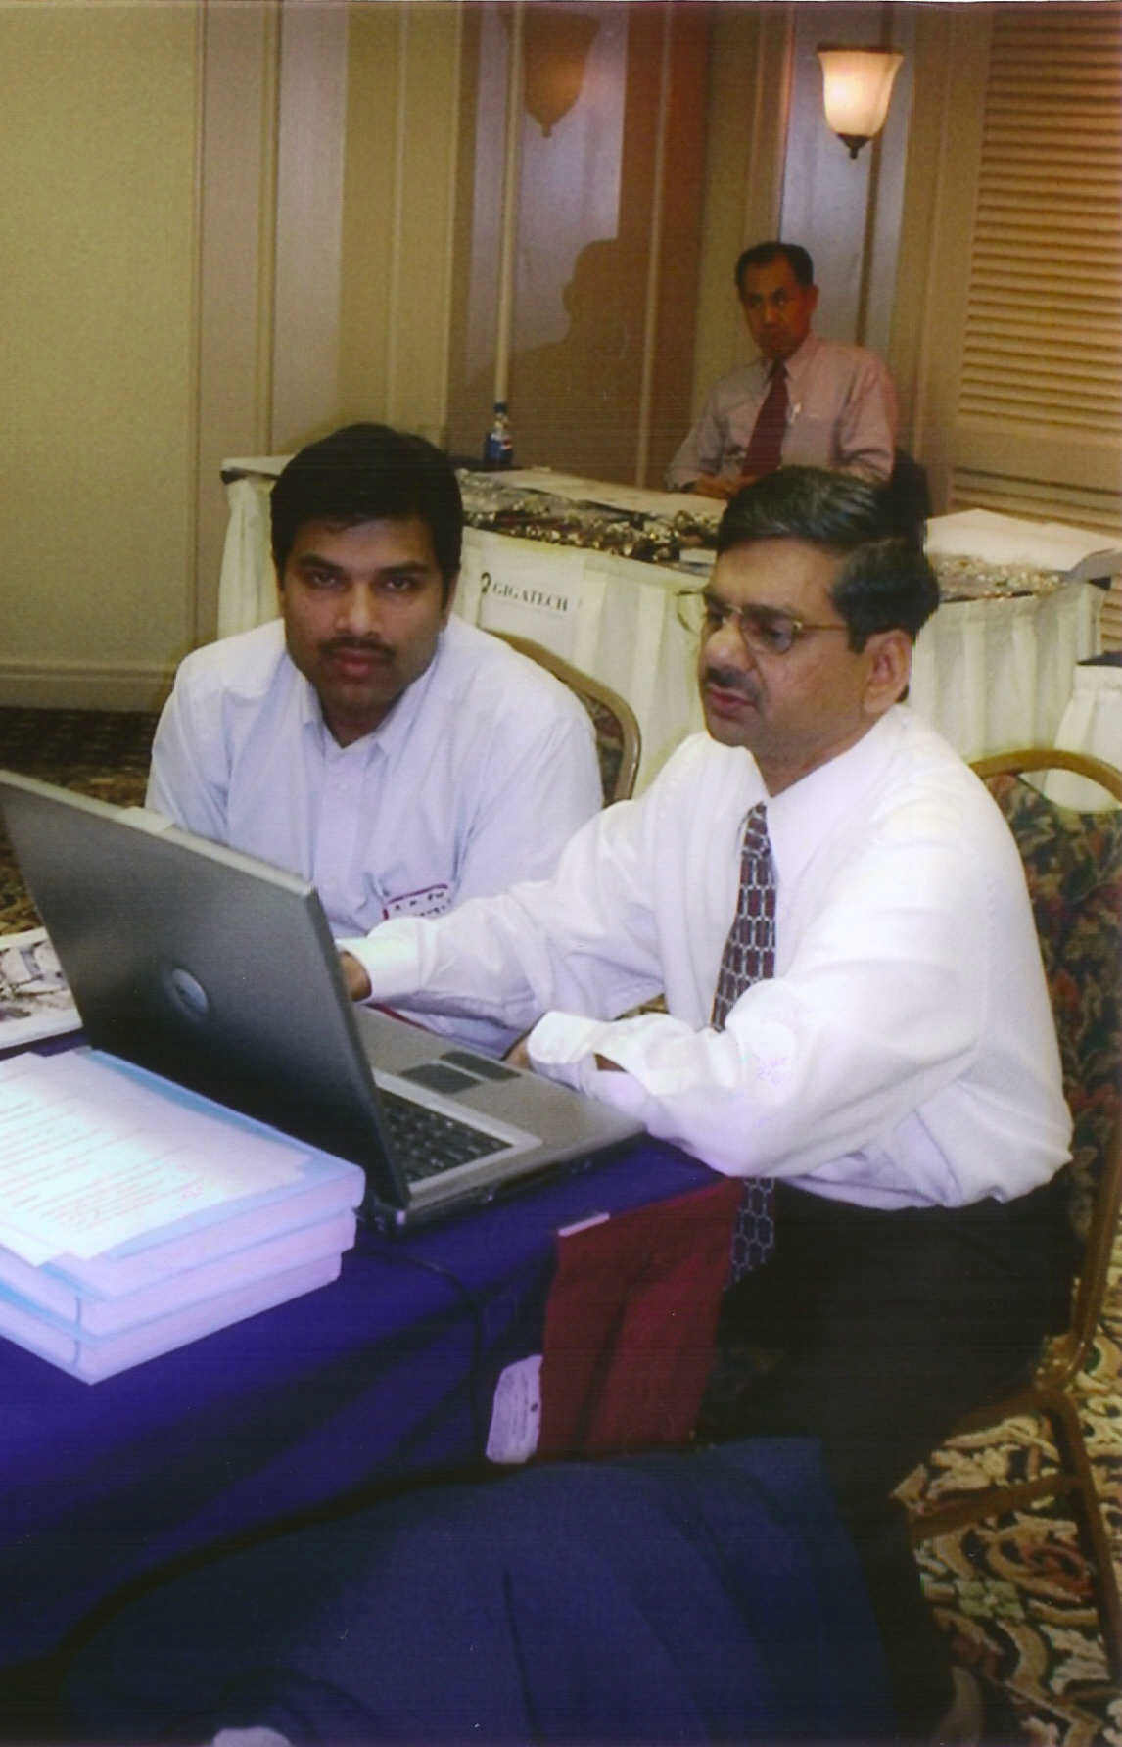
Sharing product information about new releases  and upgrades |  | Live demonstration of new software applications

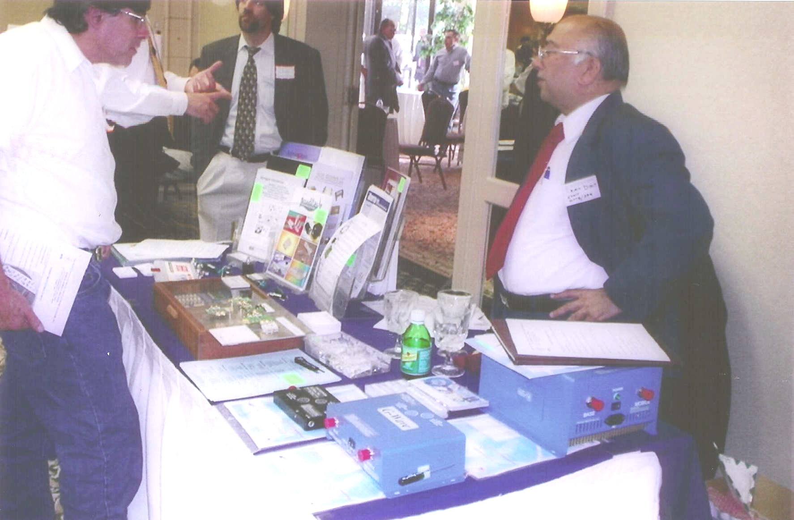
An abundance of technology and applications offered by exhibitors
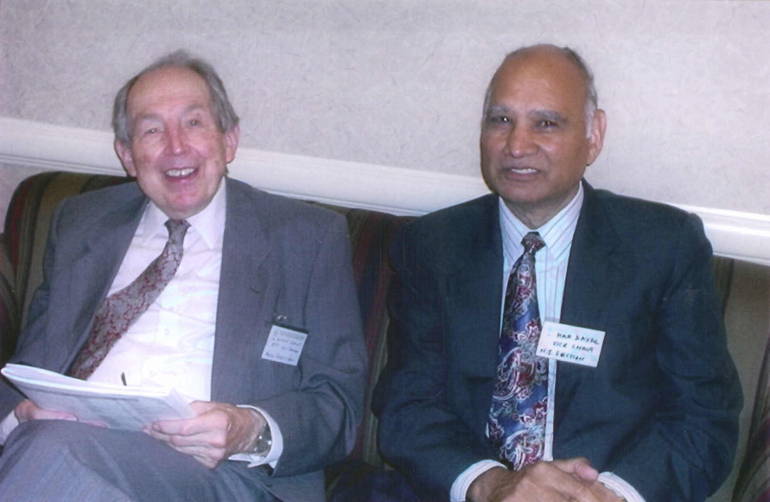
Willie Schmidt (left) reviews technical program with Har Dayal

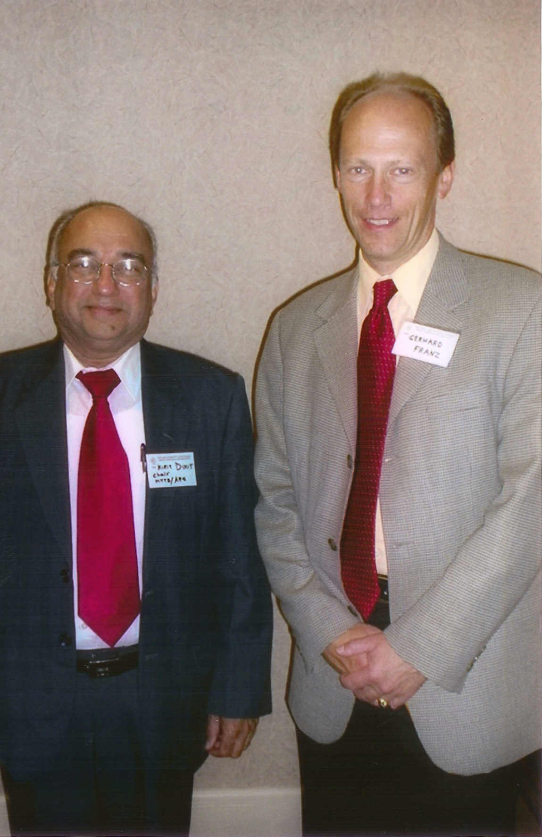
Kirit Dixit (left), Event Chair, with Gerhard Franz, Area B Chair, IEEE Region 1
Life Member Luncheon

Section Life Members met at a luncheon on November 8th to celebrate the Section’s 50th anniversary and to hear Roger Sullivan, Region I Director, discuss some of issues that the IEEE Board of Directors will be reviewing. Also, Jerry Minter was recognized as organizing and chairing the first Northern New Jersey Subsection of the IRE in October of 1947.

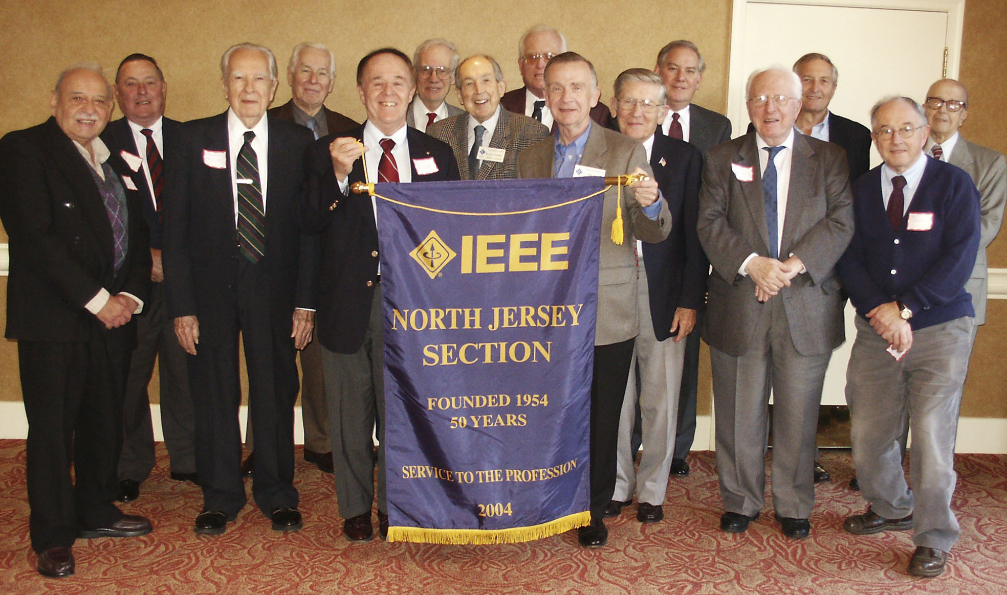

Left to Right: Naz Simonelli, Ken Hendrix, Jerry Minter, Heinz Winters, Richard Snyder, Fred Chichester, Wilhelm Schmidt, Roger Sullivan, Ken Oexle, Herb Blaicher, Carl Sulzberger, Steve Mallard, Carl Fruehling, Joe Salko, and Max Schramm

Section and Subsection Past Chairman also attended the Life member luncheon on November 8th to celebrate the Section’s 50th anniversary. Jerry Minter (shown below) organized and chaired the first Northern New Jersey Subsection of the IRE in October of 1947, 57 years ago.

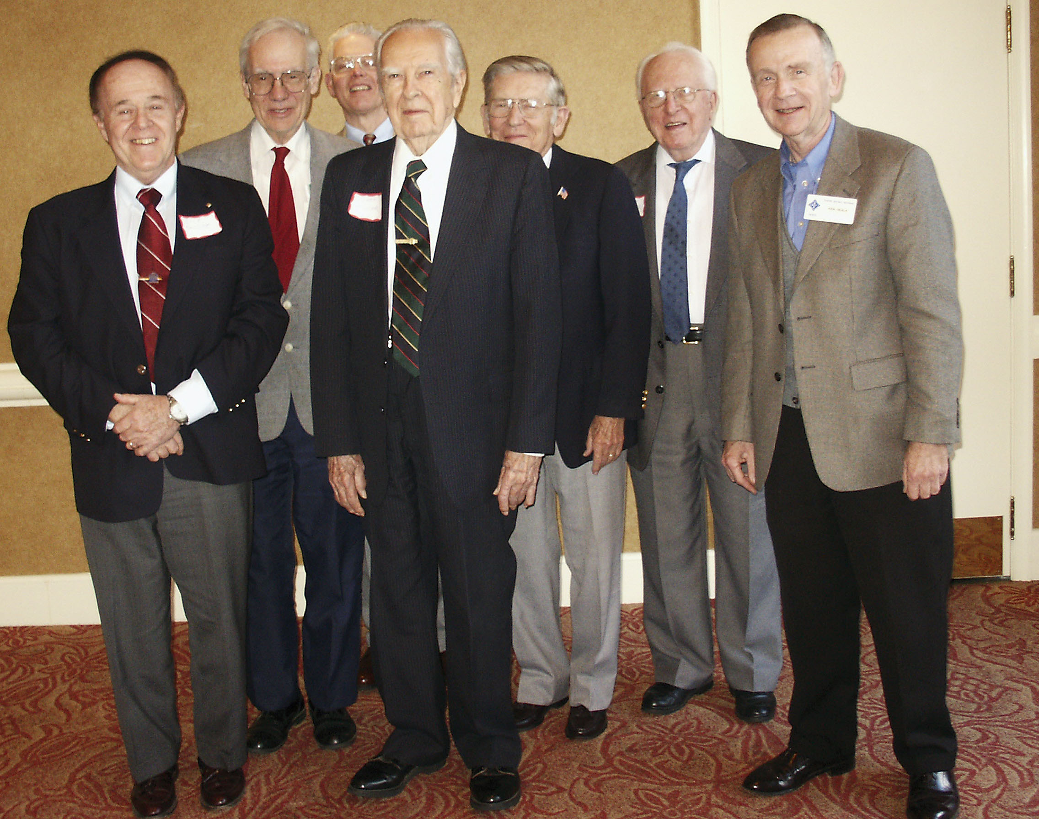

Left to Right: Richard Snyder, Fred Chichester, Howard Leach, Jerry Minter, Herb Blaicher, Steve Mallard, and Ken Oexle
A Bit of Section History
How we first got started as a Subsection of the New York Section of the I.R.E.

Jerry Minter was recognized for organizing and chairing the first Northern New Jersey Subsection of the IRE in October of 1947, 57 years ago. At that time, he contacted Dr. McReae of Bell labs and obtained the use of the new AT&T Murray Hill Auditorium, NJ, for use by the new IRE Subsection. They also used the ITT Auditorium in Nutley, NJ, and the Westinghouse Auditorium in Bloomfield, NJ, for their meetings.
This IRE Subsection became the Northern New Jersey Section of the IRE in 1954, chaired by Gordon P. McCouch 50 years ago.
The IEEE was formed on January 1, 1963 with the merger of the Institute of Radio Engineers (IRE) founded in 1912 and the American Institute of Electrical and Electronics Engineers (AIEE), founded in 1884 with Thomas Edison and Alexander Graham Bell among the first six Vice Presidents.

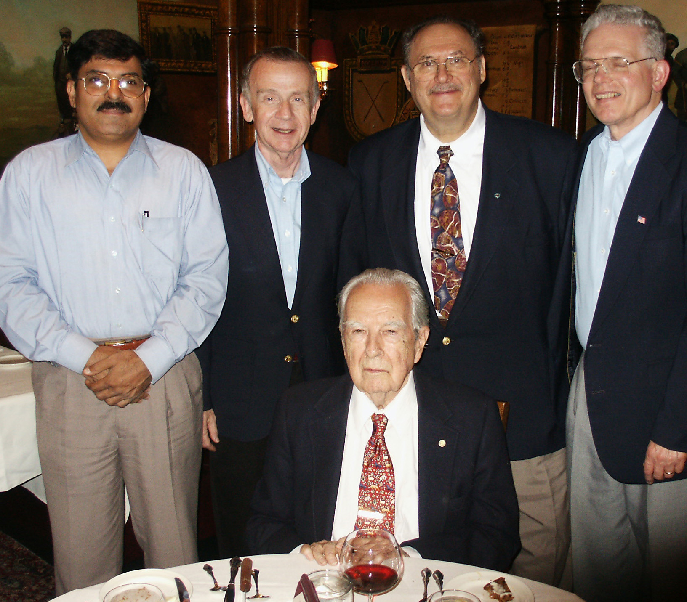

Left to Right: Durga Misra, Section Chair, Ken Oexle, Awards Chair, Jerry Minter, seated, Al Stolpen, Historian, and Howard Leach, Group Coordinator
North Jersey Section:
Minter Electronic Aircraft Safety Warning System
The North Jersey Section of the IEEE and the Lone Eagle Composite Squadron of the Civil Air Patrol will sponsor a talk on Wednesday, December 8th, entitled “Minter Electronic Aircraft Safety Warning System” by Mr. Jerry B. Minter.
About the Talk
The aircraft transponder system in present operation worldwide has some serious limitations as follows:
- The dependence on barometric pressure to determine relative altitude, and
- The lack of instant horizontal location of other aircraft transponders.
The following U.S. Parents have been issued covering solutions to the above limitations of the present transponder systems: 5,223,847; 5,506,509; 5,861,846, 5,889,491; 6,097,315; and 6,486,839. The solution uses a multimode antenna system that can locate the relative horizontal direction to another plane within one microsecond after receiving the first transponder pulse.
Lab models of the two antenna systems will be on display, however the associated electronic systems would require too much time to set up for a working demo.
The system does not generate a radiation signal so no license is required for operation.
About the Speaker
Jerry B. Minter was first employed in 1935 by the Boonton Radio Corporation, NJ, in the development of band-pass intermediate frequency transformers. In 1936 he was involved in the development of aircraft radio receivers at the Radio Frequency Laboratories of Boonton, NJ. During the later part of 1936 he was employed by the Ferris Instrument Corp., NJ, to take charge of several projects including development of a signal generator and a radio noise and field-strength meter.
In 1939, Mr. Minter and some of his associates from Ferris Instrument Corp organized the Measurements Corp. of Boonton, NJ, where he became Vice President and Chief Engineer. After much success with design and production of test equipment, the stockholders decided to sell the Measurements Corp. to the Edison Company in 1953. At that time, he had a number of conversations with Charles Edison about his father, Thomas Edison, and dined in the dining room of Edison’s West Orange Laboratory before it was turned over to the National Park Service as a National Historic Site.
In 1954, Mr. Minter bought the Components Corp. and entered into the audio business where he developed a series of special test records. In the 1960’s, the company designed and built miniature high voltage power supplies for use in high altitude probes for NASA. They also developed a high-reliability edgeboard connector called the “DigiKlip” that was used commercially in the Univac 1108, DC-10, as well as in space and military programs.
Mr. Minter also worked on video systems, one within a hospital area to reduce RF interference. In another medical project , he modified VCR’s to reduce their startup time in medical facilities within NYC. His most recent technical innovation is a passive collision warning system for small aircraft. Jerry Minter holds 26 patents of which the last six are on his aircraft collision avoidance system.
He received a BS in EE from MIT in 1934. He organized and chaired the first Northern New Jersey Subsection of the Institute of Radio Engineers (IRE) in 1947. Jerry Minter is a Fellow and past President of the Radio Club of America. He is also a past President of the Audio Engineering Society and has held memberships in the Radio Electronic Television Manufacturing Association, the Society of Automotive Engineers, the American Standards Association, and the American Society of Metals.
All Welcome!
You do not have to be a member of the IEEE or the Civil Air Patrol to attend. The North Jersey Section of the IEEE will sponsor a free buffet starting at 6 PM.

Time: 7:00 PM, Wednesday, December 8, 2004. Pre-meeting buffet starts at 6:00 PM.
Place: Public Meeting Room, Morris County Library, 30 E. Hanover Ave, Whippany, NJ, (973) 285-6930.
Information: Howard Leach (973) 540-1283, h.leach@ieee.org.
IEEE North Jersey Section Course
Marketing Research

Tuesday Evenings, February 22, 2005 through April 19, 2005 (No class on March 22)
Eight weekly classes (February 22, March 1, 8, 15, 29, April 5, 12, 19, 2005)
at NJ International Bulk Mail Center, 80 County Road, Jersey City, NJ
(Checks should not be mailed to this address)

The North Jersey Section IEEE is offering an evening course entitled "Marketing Research". Monster.com lists 450+ Market Research jobs in the New York tri-state area daily! This course deals with the collection, evaluation and analysis of the market-related information. Topics are: market research industry, problem definition, research process, focus group, secondary database, quantitative research, questionnaire design, sampling techniques, statistical testing, bivariate and multivariate correlation, communicating results and management reports. Using the SPSS software, you will learn to perform detailed data analysis.

The IEEE certificate of completion will be given to you when you finished this course. In addition, you will be qualified to work as a market researcher in any organization that needs your quantitative skills.

Instructor: Donald Hsu, PhD, has been a corporate manager for 11 years and is an experienced trainer. Since 2000, he has trained 400+ people in Management, Marketing, Global Marketing, and Marketing Research courses in five organizations.

TOPICS
- Describe the market research industry, problems and research process
- Understand the importance of primary data collection, secondary database, and survey
- Define quantitative research, measurement technique and sampling methods
- Explain the questionnaire design, data processing and statistical testing
- Build the knowledge of bivariate regression and multivariate data analysis
- Communicate results, manage ethical issues, and prepare reports
- Employ SPSS software for frequency analysis, ANOVA, T-test and others
- Review real-world marketing research using Harvard Business School cases
- Present final Group Project

Class size will be limited to a maximum of 25 with a minimum of 15. Early registration is recommended. Phone reservations will NOT be accepted. Reservations accepted after February 10, 2005 will require a late fee of $25. No reservations will be accepted after February 15, 2005.
WHERE: | NJ International Bulk Mail Center, 80 County Road, Jersey City, NJ. (Checks should not be mailed to this address)
WHEN: | 8 Sessions, Tuesdays, February 22, March 1, 8, 15, 29, April 5, 12, 19, 2005, 6:30-9:30 PM.
COST: | With textbook or notes: IEEE (& affiliate) members $375; Non-IEEE members $475.
CONTACT: | Bhanu Chivakula -email b.chivakula@computer.org

REGISTRATION: Marketing Research

Please send the checks in the name of North Jersey Section IEEE with filled in registrations to:
Bhanu Chivakula, 19 Prestwick Way, Edison, NJ 08820. Please email inquiries to b.chivakula@computer.org

Name: / Mr. / Mrs. / Miss / Ms. / _____________________________________________ _________________________________
 Non-member email address
 IEEE Member Member #:_________________________ Member of _____________________________ technical society

Employer:___________________________________________________________________________________________________

Employer Address:____________________________________________________________________________________________

___________________________________________________________________________________________________________

Home Address:______________________________________________________________________________________________

___________________________________________________________________________________________________________

Business (day) telephone #:___________________________________ Home telephone #:________________________________

Please enclose required fee payable to: North Jersey Section IEEE
Registration status will be mailed after February 15, 2005. Phone inquiries concerning registration will NOT be honored. In general, the effective date of the application corresponds to the date when BOTH a fully completed application/registration and payment are received.

 Tuition receipt will be mailed only if this box is checked Signature:___________________________________________

